Assignment no.5
5)we have github project include war file, now you uploading that war file date wise in s3 by using jenking job, date need to disaply, aslo downloading war file in tomcat from s3. hint need iam experiance.
Ans.
Launch ec2 jenkin master instance with below steps
2nd menthod ---- here jenkin home directory is diffrent /root/.jenkins/
install java and tomcat deploy war file.
1)luanch ec2 instance -
yum list java-17-amazon*
2) install java ----- yum install java-17-amazon
3) create folder in /mnt ----- mkdir /mnt/servers
4) install tomcat 10 ---- wget https://dlcdn.apache.org/tomcat/tomcat-10/v10.1.53/bin/apache-tomcat-10.1.53.zip
5)unzip apache-tomcat-10.1.53.zip
6)rm -rf apache-tomcat-10.1.53.zip
7) chmod -R 777 apache-tomcat-10.1.53
8) cd apache-tomcat-10.1.53
9) cd webapps/
10)go to link and select latest Jenkins WAR file --- https://www.jenkins.io/doc/book/installing/war-file/
11)select past release option https://get.jenkins.io/war-stable/
12 select latest --> select jenkins.war file option.
13)wget https://get.jenkins.io/war-stable/latest/jenkins.war
14) cd ../
15) cd bin
16) ./startup.sh
17) cd ../
18) cd logs/
19) tail -100f catalina.out

- Install MVN --- yum install mvn -y
Create folder on ec2 instance and get war apache file
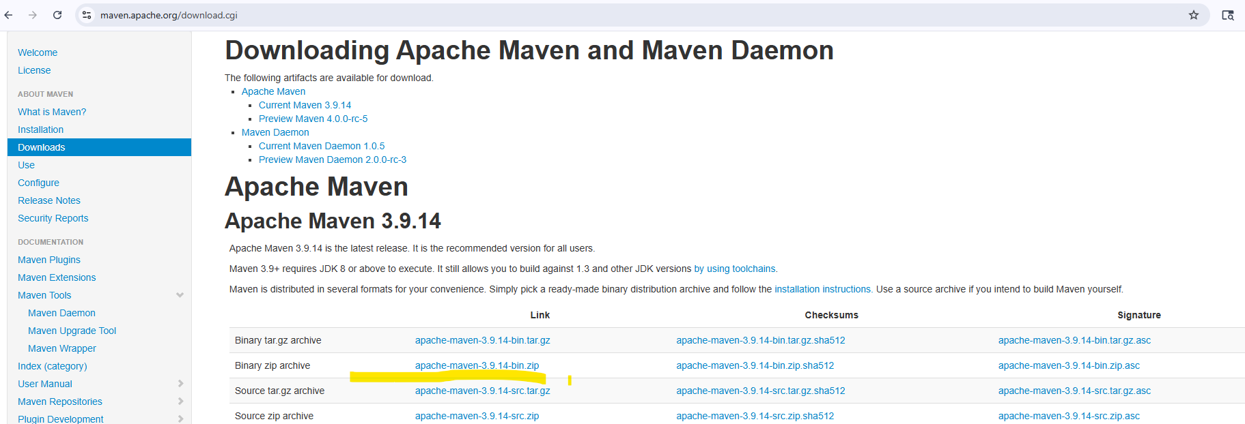
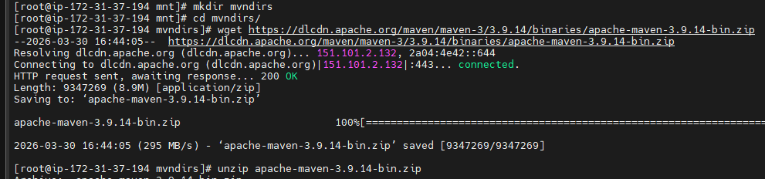
Then Configure maven in jenkins. Go to manage jenkins > tools > maven installations > add maven > give version name and define MAVEN_HOME
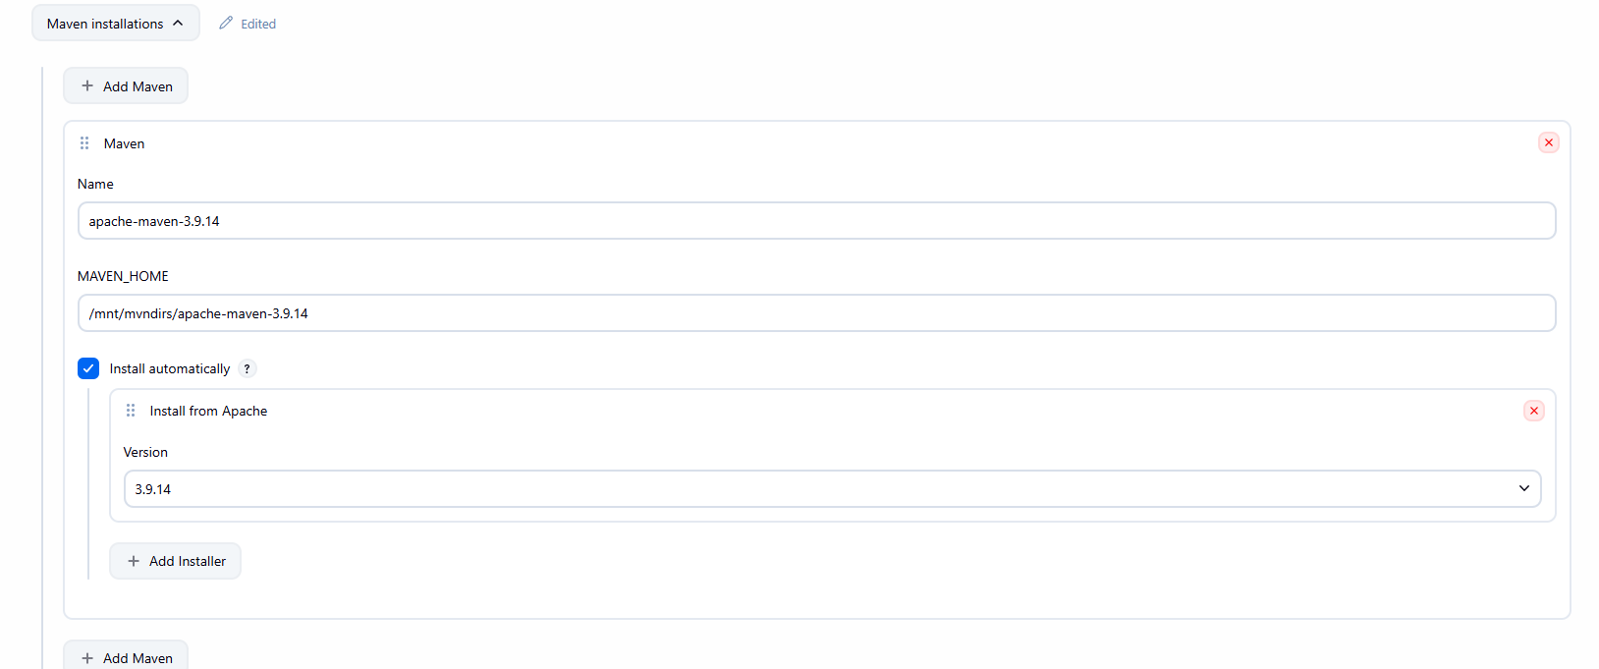
- . Go to our Ec2 instance and configure AWS CLI so that we can use S3 CLI commands in our jenkins job. We need aws access keys for this. Generate them from AWS IAM.

- On our github we have project repo containing source code and pom file for our login webapp. Find out war file name that would be generated after maven packages src. We will clone this repo to our jenkins master later.

- Now go to jenkins dash and create a job. Create custom workspace /mnt/project. Our target folder will be located here. In source code management add your repo URL. In Environments enable “Delete workspace before build starts”, this is useful as we are creating multiple builds.

- Add one more build step and select “Invoke top-level Maven targets”. Select version of maven we have added to jenkins in tools. In goals insert command
clean package

- Add one more build step select execute shell. Here we will clear our workspace and create S3 bucket. Also we will upload war file to S3. We need timestamp in war file name. For this we first create shell variable and call it while running command to copy war file. See the script below

#Delete existing bucket
aws s3 rb s3://myapp-war-bucket-sandeep --force
#create shell variable and create bucket
TIMESTAMP=$(date +"%d%m%Y-%H%M")
aws s3 mb s3://myapp-war-bucket-sandeep
#Upload war file with timestamp to S3
aws s3 cp /mnt/project/target/LoginWebApp.war s3://myapp-war-bucket-sandeep/LoginWebApp-$TIMESTAMP.war
#Download war file and deploy to apache
aws s3 cp s3://myapp-war-bucket-sandeep/LoginWebApp-$TIMESTAMP.war /mnt/servers/apache-tomcat-10.1.53/webapps/LoginWebApp.war

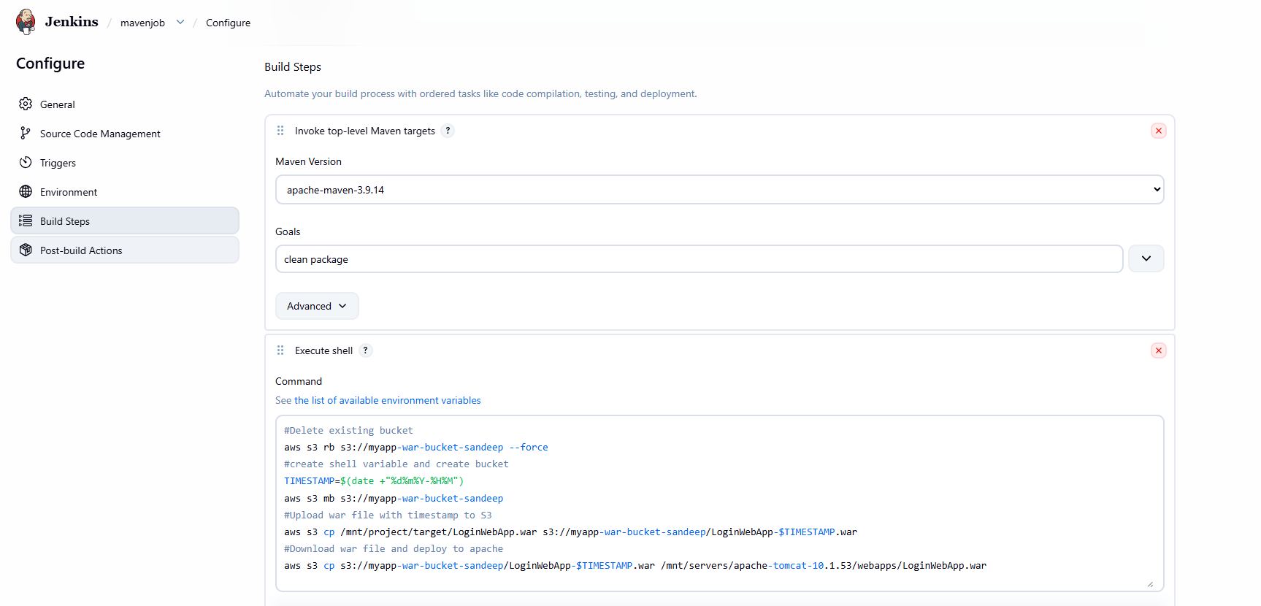

Output
